# How to restore a backup from an USB stick

First of all we insert our USB stick into the PC. After that we open the USB stick folder and we navigate to the backup file.

Let’s now copy the file

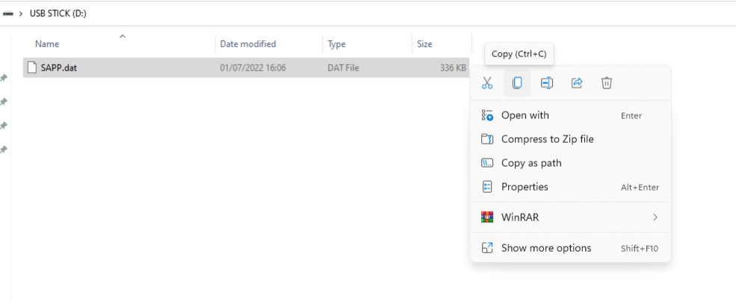

After that we have to navigate to the wallet data directory located in %appdata% as shown in the picture (Windows 11).

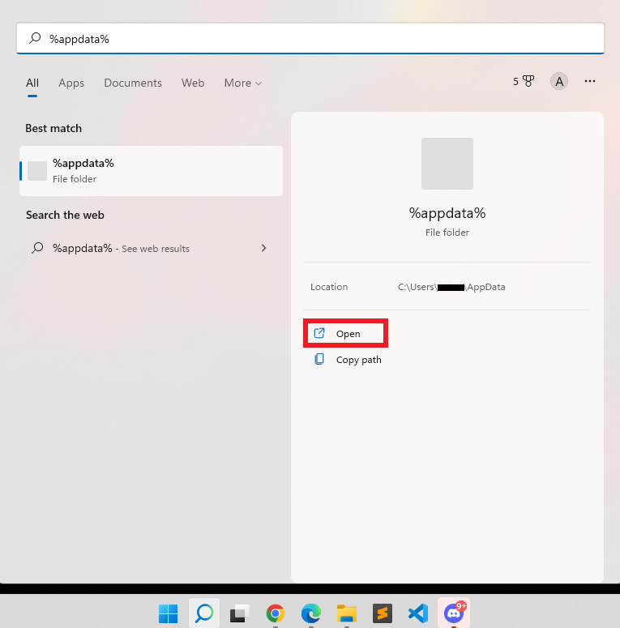

We can now open the coin’s folder we are looking for (in our case Sapphire)

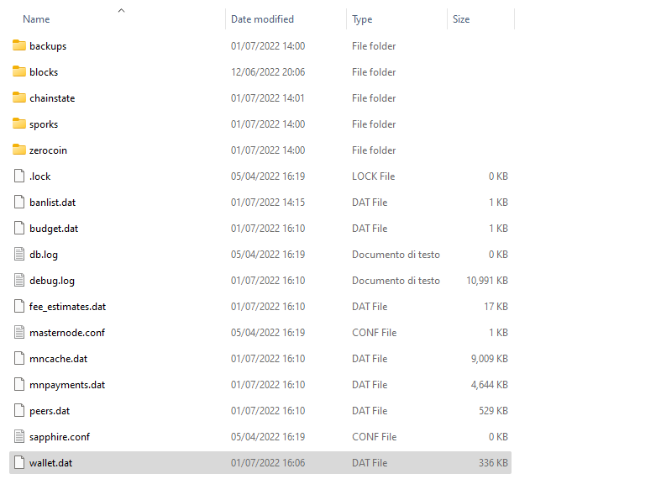

**NB The file name must always be wallet.dat** so we need to rename the old one first.

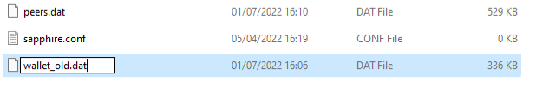

We can now paste the file we copied previously from the USB stick

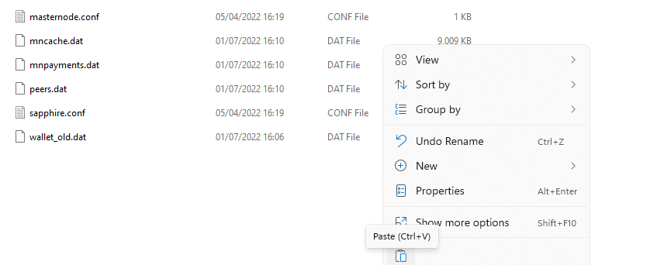

As final step we rename the file to wallet.dat

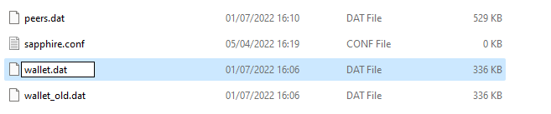

The wallet is restored and we can start our Sapphire wallet.  
  
**NB As already mentioned make sure the wallet file name is wallet.dat otherwise your wallet will not recognize it.  
Do not move or rename other files or data directory.**